Evaluation Communication
and Knowledge Management
Plan for Decentralized Evaluations

- Introduction
- WFP’s Evaluation Policy, in line with international standards on evaluation, requires that all evaluation reports are made publicly available and disseminated widely. For this, WFP Evaluation Communications and Knowledge Management Strategy (2021-2026) focuses on promoting evaluation use across diverse audiences, raising greater awareness of the evaluation function and embedding an evaluation culture among WFP employees. Emphasis is placed on knowledge sharing and knowledge access for which communication activities and approaches are crucial to engage effectively with different internal and external audiences in the pursuit of learning
- The purpose of this note is to ensure that evidence emerging from decentralized evaluations is consistently made available and accessible to all internal and external stakeholders for accountability, learning and decision-making, ensuring that learning continues long after the evaluation process has been completed. Key audiences should be engaged through well timed and well tailored products on targeted channels using different technologies.
2. What is a Communication and Knowledge Management Plan?
- For each evaluation, a communication and knowledge management plan (see table 1) should be created by the evaluation manager, with inputs from the evaluation reference group, the CO/RO communications and/or knowledge management officer and, if needed, the Office of Evaluation Knowledge Management, Communications and Use Unit.
- The plan should be set up during the preparation phase of the evaluation, attached to the Terms of Reference, and run through the dissemination and follow-up phases. It should be updated with additional information where relevant as the evaluation progresses. The plan should identify communication/ knowledge management products, channels and key audiences (see mapping in figure 1).
- The key standard products of the evaluation are the terms of reference, the inception report and the evaluation report. The Communication and Knowledge Management Plan distinguishes between main products (mandatory) and associated products (optional) and knowledge management products (optional). Associated content could include infographics, videos, podcasts, posters, picture stories, blogs, features and interviews (see examples in annex 1). Knowledge management products could include lessons learned papers, webinars, blogs and articles for communities of practice.

- How does it look and what does it include?
- Table 1 presents an example of Communication and Knowledge Management plan. This is illustrative and should be contextualized based on the structure of the CO and the specificities of the subject being evaluated. It is important to note that for each phase of the evaluation, there will be more than one product and target group.

Table 1. Communication and Knowledge Management Plan
When  Evaluation phase | What  Product | To whom  Target audience | From whom  Creator lead | How  Communication channel | Why  Communication purpose
Preparation | Draft TOR | Evaluation Reference Group | Evaluation manager | Email: ERG meeting if required | To request review of and comments on TOR
Preparation | Final TOR | Evaluation Reference Group; WFP Management; Evaluation community; WFP employees | Evaluation manager | Email; WFPgo; WFP.org | To inform of the final or agreed upon overall plan, purpose, scope and timing of the evaluation
Inception | Draft Inception report | Evaluation Reference Group | Evaluation manager | Email | To request review of and comments on IR
Inception | Final Inception Report | Evaluation Reference Group; WFP employees; WFP evaluation cadre | Evaluation manager | Email; WFPgo | To inform key stakeholders of the detailed plan for the evaluation, including critical dates and milestones, sites to be visited, stakeholders to be engaged etc.
Data collection | Debriefing power-point | Commissioning office management and programme staff; Evaluation Reference Group | Team leader (may be sent to EM who then forwards to the relevant staff) | Meeting | To invite key stakeholders to discuss the preliminary findings
Reporting | Draft Evaluation report | Evaluation Reference Group | Evaluation manager | Email | To request review of and comments on ER
Reporting | Validation workshop power-point and visual thinking | Commissioning office management and programme staff; Evaluation Reference Group; partners | Evaluation manager and Team Leader | Meeting | To discuss preliminary conclusions and recommendations
Reporting | Final Evaluation report | Evaluation Reference Group; WFP Management; donors and partners; Evaluation community; WFP employees; general public | Evaluation manager | Email; WFPgo; WFP.org; Evaluation Network platforms (e.g. UNEG, ALNAP) | To inform key stakeholders of the final main product from the evaluation and make the report available publicly
Dissemination & Follow-up | Draft Management Response | Evaluation Reference Group; CO Programme staff; CO M&E staff; Senior Regional Programme Adviser | Evaluation manager | Email and/or a webinar | To discuss the commissioning office’s actions to address the evaluation recommendations and elicit comments
Dissemination & Follow-up | Final Management Response | Evaluation Reference Group; WFP Management; WFP employees; general public | Evaluation manager | Email; WFPgo; WFP.org; | To ensure that all relevant staff are informed of the commitments made on taking actions and make the Management Response publicly available
Dissemination & Follow-up (Associated Content) | Evaluation Brief | WFP Management; WFP employees; donors and partners; National decision-makers | Evaluation manager | WFP.org, WFPgo | To disseminate evaluation findings
Dissemination & Follow-up (Associated Content) | Infographics, posters & data visualisation | Donors and partners; Evaluation community; National decision-makers; Affected populations, beneficiaries and communities; General public | Evaluation Team; OEV/RO/CO Communications/ KM/Use unit | WFP.org, WFPgo; Evaluation Network platforms (e.g. UNEG, ALNAP); Newsletter; business card fo event; radio programmes; theater/drama, town-hall meetings; exhibition space | To disseminate evaluation findings
Dissemination & Follow-up (Associated Content) | Video
Dissemination & Follow-up (Associated Content) | Blog, lessons learned papers, tailored briefs, summaries of findings |  | Evaluation manager |  | To disseminate evaluation findings
- Target audience and communication channels
- The Communication and Knowledge Management plan does not offer a prescriptive guide on how to communicate to different stakeholders identified in the stakeholder analysis. It rather focuses on creating tailored products for different target audiences at key phases of the evaluation in order to optimize evaluation use.
- The plan should dedicate attention to developing products and channeling knowledge to audiences identified in the stakeholder analysis, ensuring that communications are tailored and directed to the most relevant audience (figure 1). Particular attention should be paid to direct users of evaluation evidence, and other stakeholders who may benefit from, have an interest in or be affected by the evaluation findings. Annex 2 provides a mapping of products and channels to different audiences.
- Through the plan, the evaluation manager should identify and plan ahead for key events/ fora where the evaluation results can be shared. It may be beneficial to involve the evaluation team (especially the team leader) in some communication processes at a later stage after the evaluation is completed (the contractual arrangements should ensure that there is provision for this). The plan should make clear the respective roles and responsibilities of the evaluation team and the commissioning office throughout the evaluation (i.e., identifying who is the creator lead).
- Particular attention should be paid to potential means and channels of communicating with and disseminating results to affected populations, notably individuals/groups who are marginalized. The evaluation manager is encouraged to develop evaluation products that reduce barriers to information and exchange lessons and experiences. Such products and channels may include the translation of key messages into local languages, use of local radio broadcasting, video media clips, visual presentations, posters, public announcements, mobile and social media, community consultations and stakeholder workshops. Furthermore, the evaluation manager might create opportunities with other evaluation colleagues to discuss and compare experiences in this area for ensuring good practice.
- The plan should also pay attention at how findings on Gender Equality and the Empowerment of Women (GEEW) can be disseminated and used, and how stakeholders interested or affected by GEEW issues will be engaged in the process. It should promote the fullest possible use of GEEW findings of the evaluation within the UN system, NGOs partners, and the Government stakeholders.

Figure 1: The key audiences of a communication plan
Communication Means

Debriefing
Meetings/briefings
Workshop
Brown bag
Email
WFP websites
WFP Online Evaluation Community
WFP Online Thematic Communities
Partner website
Video and Radio
News media (print)
Broadcast media
Panel presentation
Poster session
Social media
 | WFP Management who use evaluation evidence to make decisions about the organization’s future direction.
 | Donors and partners who are responsible for reporting on the performance of their investments, and employ evidence produced in evaluations to demonstrate impact and build cases for future partnerships and relationships with WFP.
 | WFP employees, including evaluation cadre, who foster evaluation culture and practice, utilizing evidence generated by evaluations to make decisions about how to construct new or reshape existing policies, programmes, strategies and plans.
 | Affected populations, beneficiaries and communities who have often participated in the evaluation process and are directly affected by corresponding decisions taken. Their ownership of future policy is crucial to its success.
 | National decision-makers who have invested in WFP projects and programmes and, as their country’s representatives, may find evaluation evidence useful to inform their actions.
 | Evaluation and humanitarian-development communities who are constantly engaged in sharing insights to raise awareness and improve the discipline of evaluation, and spreading knowledge, best practices relevant to humanitarian-development actions aimed at achieving the 2030 Agenda.

 | General Public who ultimately decide investments made in humanitarian-development projects based on independent accounts of their performance and connection with goals of the 2030 Agenda.

Annex 1. Examples of communication products

Illustration 1. Drawing the change Illustration 2. Townhall
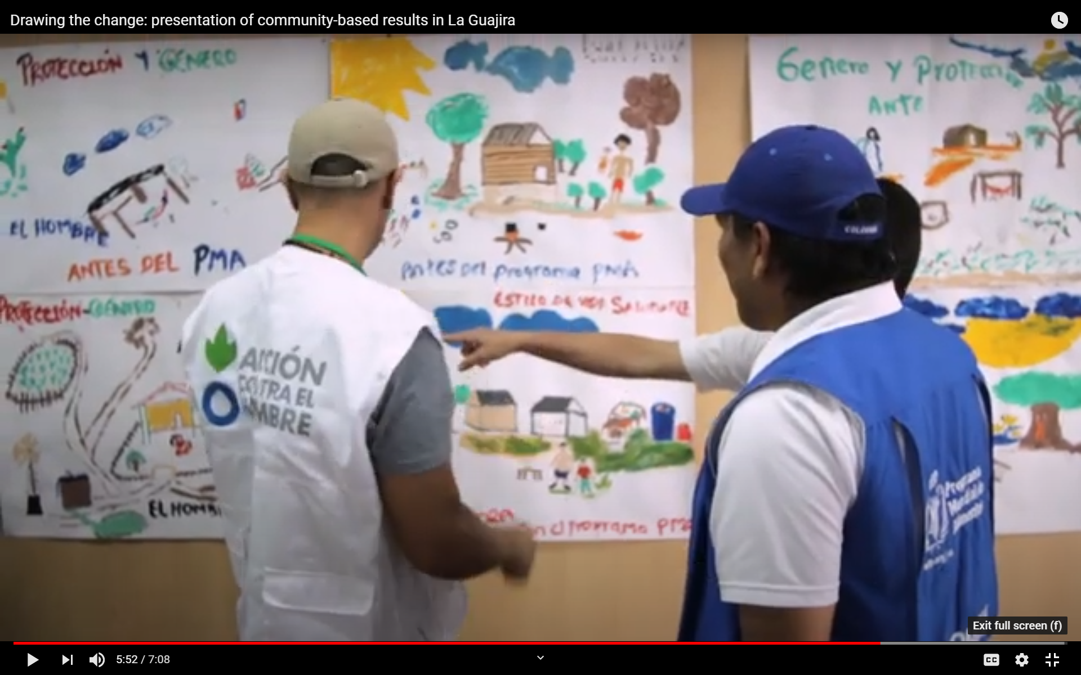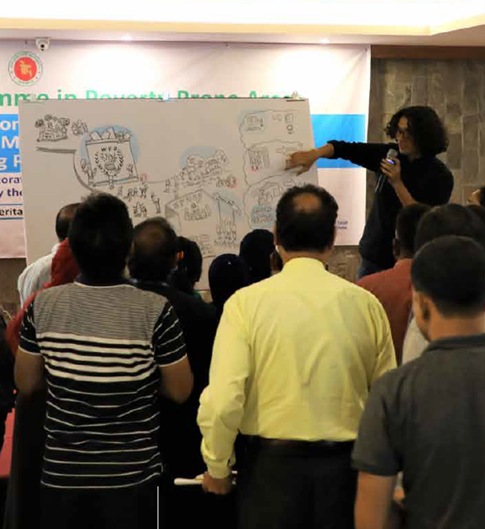

Illustration 3. Event business card Illustration 4. Infographics
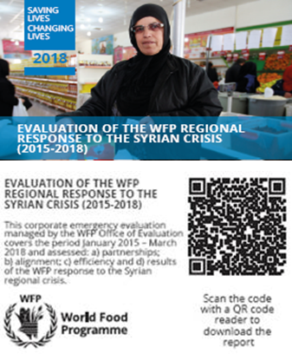
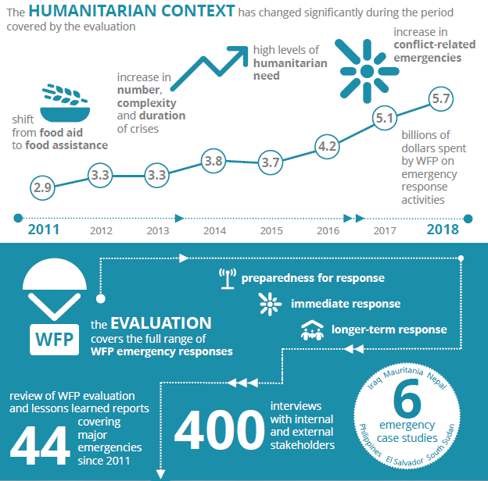

Annex 2. Mapping Audiences, Products & Channels
This graphic maps products (light blue) and channels (dark blue) to audiences (green). The proximity of products and channels to audiences demonstrates a closer relationship.

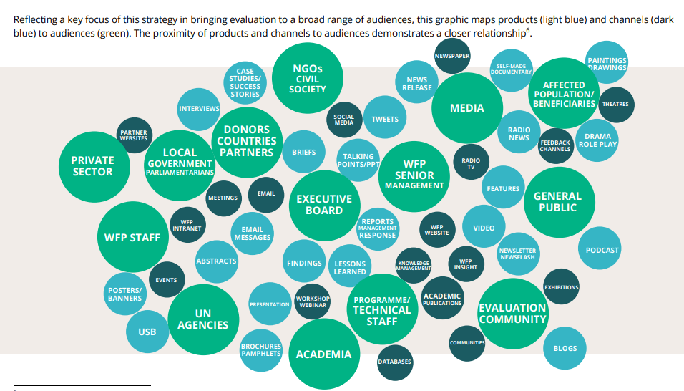

See WFP visual thinking evaluation workshop video from Sri Lanka CO on climate change DE (here and here).
See the example of the Strategic Evaluation of WFP’s Capacity to Respond to Emergencies.
See the example of Data viz in the Annual Evaluation Report.
See the example of the Senegal evaluation and the Colombia evaluation.
See the example of El Salvador Gender DE video.
Reference materials on how to develop an evaluation dissemination strategy can be found in the tools 15 and 15A of the 2015 UNWOMEN guide “How to Manage Gender-Responsive Evaluation”.
The identification of audiences, products and channels, including their proximity, presented in this map was the result of a collaborative session with evaluation managers from country offices and HQ during a learning session of EvalPro4 in October 2019.

