Quick guide: CO Targeting & Prioritization documentation requirements
With the issuance of the Executive Director’s circular on Management of Targeting Processes by WFP Offices (December, 2022), new requirements on WFP country offices (COs) come into effect as it relates to the documentation of targeting and prioritization plans and decisions (in particular paragraphs 8 and 13).
The circular seeks to address issues flagged by WFP’s mechanisms for internal and external oversight, such as the 2020 Internal Audit of Beneficiary Targeting in WFP Office and the 2021 external audit report on The Management of Information on Beneficiaries. Among the agreed actions to be addressed is the re-establishing of targeting as an activity core to achieve intended outcomes across all operations, and the establishing of minimum requirements for documentation of targeting and prioritization decisions.
This note aims to guide COs in adhering to the documentation requirements at i) strategic (CSP) level, and ii) operational (activity) level.
CSP-level documentation
“Targeting decisions shall to the extent possible promote coherence and complementarity across i) CSP activities; ii) activities of humanitarian and development partners; and iii) relevant services and public support by host governments, to achieve the best possible outcomes with available resources. To this end, country offices shall for the duration of the CSP period, establish a targeting strategy outlining interlinkages across activities and with partners.”
- ED circular on Management of Targeting Processes by WFP Offices (paragraph 8)
The process of developing and documenting Country Strategic Plans (CSPs) establishes WFP’s operating space and intended achievements in a given context and timeframe. While section 4 (‘Beneficiary analysis’) as per the CSP pro forma should outline broad intentions for how to target and, if needed, prioritize beneficiaries to facilitate these achievements, the proposed 200-word allocation in reality only allow CSPs to provide a fragmented picture of how and why this will happen (e.g. covering only one or few activities, accounting for only part of evidence to inform decisions, etc.).
In support of the ED circular’s aim to ensure that targeting is treated as core to WFP’s ability to reach its objectives, the Targeting Strategy provide COs a space where they can better explain their intentions and considerations. The document is expected to be brief, will not be subject to the CSP review and approval process and is not mandatory to make publicly available. However, since indicated as a requirement in the ED circular the Targeting Strategy may be considered in the work of WFP’s oversight functions, such as the Office of the Inspector General’s Internal Audit function.
As indicated in the ED circular, the CSP-level Targeting Strategy should explain how the CO, given the outlined contextual environment and the space WFP is claiming within it, consider synergies in targeting i) within the WFP programme of work, ii) with the work of other humanitarian and development actors and iii) host government social protection and services in order to achieve maximum impact with the CSP budget.
While the specific content of the strategy will vary with factors such as the operational context and the type and size of WFP programmes, the following presents a generic outline of information that is recommended to document at CSP-level:

Example outline for targeting documentation at CSP-level
- Background and CSP overview
- Reference the CSP that the Targeting Strategy complements and its duration
- Briefly outline the strategic outcomes and activities to be implemented
- Indicate whether the CSP foresees any significant changes to the current caseload during the CSP period (e.g. a reduction in the number of people benefitting from unconditional resource transfers, i.e. General Food Assistance)
- Highlight any other strategic issues of importance introduced/amplified through the CSP that is expected to impact who is provided assistance and how they are selected (e.g. evolving context, evidence pointing towards shifting needs, etc.)

- Partners and their activities impacting WFP’s targeting and prioritization
- Building on the partnership context outlined in the CSP, indicate specific partners (humanitarian/development organizations, International Financial Institutions, host government, etc.) and their activities which the CO is/will be taking into account when targeting and/or prioritizing beneficiaries for the CSP activities
- Describe if and how WFP’s plans to take partners’ targeting into account to achieve the highest possible impact, by e.g., complementing assistance to specific vulnerable groups and/or not assisting certain population groups covered by other interventions. Type of issues to cover may include:
  - UNHCR vs. WFP’s assistance to refugee populations, and
  - WFP action warranted due to marginalized populations being systematically excluded from national social protection systems

- Synergies across CSP programme of work
- Explain how targeting and prioritization for the strategic outcomes and activities in the CSP aims to strengthen overall effectiveness of WFP’s portfolio. Type of issues to cover may include:
  - If WFP during the CSP period is intending to reduce its URT/General Food Assistance caseload, how is the CO planning to mitigate the potential negative impact? Will resilience and livelihood activities to specifically target populations excluded from unconditional assistance?
  - Will areas and schools selected for WFP’s school-based programmes are targeted in view of access to assistance and other services?
  - Will WFP as part of its targeting and prioritization plans advocate for inclusion of specific population groups into national safety nets?

- Internal and external coordination mechanisms
- Outline how the CO intends to ensure coordination in the planning and execution of targeting and prioritization decisions:
  - internally across SO/activities through the ED circular-mandated CO targeting governance structure (e.g. a cross-functional Targeting Working Group); and
  - with external partners and/or interagency mechanisms.

Activity-level documentation
Paragraph 13 of the ED circular on Management of Targeting Processes by WFP Offices details the information which needs to be documented at CSP activity level (for all activities under implementation):
“In addition to the CSP-wide targeting strategy and regular monitoring of targeting processes and outcomes, Country Directors shall ensure that targeting and prioritization decisions for CSP activities are systematically documented and that documentation is updated in light of strategic and operational changes. At a minimum, the following shall be clearly outlined for each CSP activity under implementation:
a) How targeting and prioritization decisions for the activity are made and implemented, including country office governance and the roles and responsibilities of WFP staff, cooperating partners and other external stakeholders.
b) Targeting and/or prioritization methodology and rationale behind targeting design decisions.
c) How quantitative and qualitative information generated through household surveys, community and expert consultations, and other means of inclusive data collection, inform decisions on eligibility criteria for inclusion to assistance.
d) How the country office seeks to ensure cohesion and complementarity between the activity and i) across other CSP activities, and ii) with targeting of relevant programmes implemented by partners, including humanitarian, development and government actors (at activity-level).
e) How targeting decisions are communicated to affected populations, and what mechanisms that are in place to receive and deal with appeals, complaints and community feedback.
f) How targeting processes and key outcomes are monitored and improved over time.
g) How risks related to the targeting or prioritization for the activities and related mitigation measures are embedded with regular country office risk management processes.”

Example outline for targeting documentation at activity-level
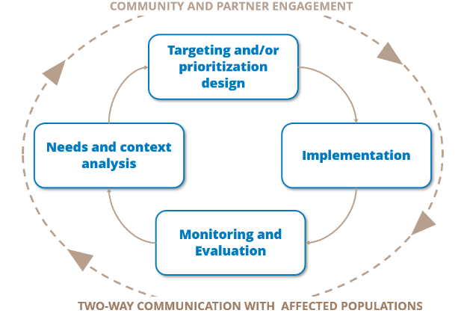
Several country-level and eventually the thematic global internal audit on WFP’s targeting has highlighted the lack of comprehensive documentation on targeting decisions as a major gap in accountability, resulting in negative operational impacts as well. The circular therefore mandates all COs to systematically document the above key parameters for all CSP activities. In order to adhere to these requirements, COs are encouraged to document points B – F above following WFP’s corporate approach to targeting as a guide:
1) Needs and context analysis
- Outline information obtained from quantitative and qualitative sources of information that explains the relevant context and objectives of the activity in question (e.g. key outcomes such as food security, economic capacity to meet essential needs, specific protection and gender risks)
2) Targeting and prioritization design
- Explain how the above-mentioned information on needs and context is used to inform:
  - The selection of targeting methodology
  - Preliminary eligibility criteria (association tests, precision testing, etc.)
  - Consultations with communities and other key stakeholders
  - Finalization of eligibility criteria and thresholds
  - A communication and sensitization strategy
3) Implementation
- Explain how WFP and partners will go about applying the eligibility criteria to the population of interest to generate a beneficiary list
- What provisions are made regarding spot-check verification of eligibility criteria
- If and how the population will be registered, and which information pertinent to targeting and, if needed, prioritization, that will be gathered
- What mechanisms for appeals will be available and how will cases be assessed and feedback provided
- What regular means of communication that are available to assisted and non-assisted populations and planned frequency of communication
4) Monitoring and evaluation
- How process and outcome monitoring data will be gathered and analysed with a targeting lens
- If targeting of the activity will be covered in the CSP- and/or decentralized evaluations planned for the CSP duration.
In addition, the CO is recommended to include the following information related to ED circular documentation requirements
13 a) Roles and responsibilities: Outline which functions in the CO and among cooperating partners and other stakeholders that are involved in the targeting process, and what their roles and deliverables are; and
13 g) Risk management: Which specific risks related to targeting for the activity have been identified and included in the CO risk register, with what mitigation measures?

