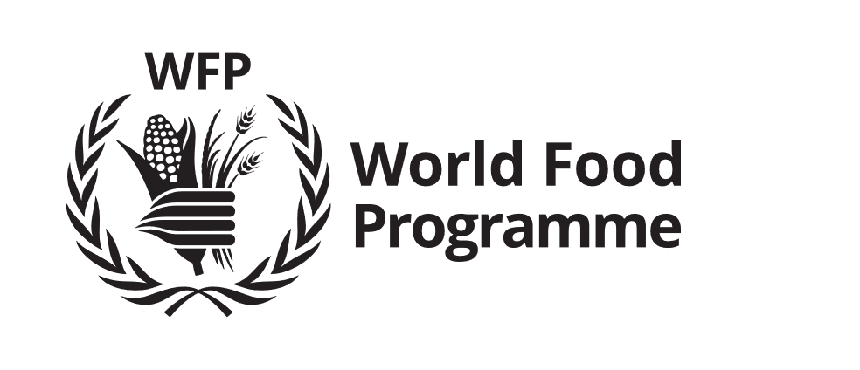 | Field Level Agreement

WFP Special Conditions for Implementation and Monitoring of Cash and Vouchers Activities

1. The Cooperating Partner shall implement the activities described in the Plan of Operations.

2. Under these Special Conditions, the Cooperating Partner shall carry out functions related to the implementation of a cash and vouchers program, but shall not be required to arrange distribution of funds (the “Benefits”) to beneficiaries directly or via an intermediary or to arrange payment of funds to retailers approved by WFP (the “Retailers”) against remittance of redeemed vouchers (the “Retailer Funds”).

3. The Budget shall comprise the costs and management service charge payable by WFP to the Cooperating Partner for the activities implemented under this Agreement (the “Cooperating Partner Costs”) payable by WFP in arrears, in accordance with Section E below. The Budget shall contain fully justified elements for: (a) Delivery; (b) Technical or Specialist Services; (c) Management and Administration and (d) a Management Fee equal to 7% of the aforementioned costs. Start-up and close-down costs included in the Budget will be specifically identified.

Section A – Special Obligations of the Cooperating Partner

4. In addition to its obligations under the WFP General Conditions of the Field Level Agreement (“General Conditions”), the Cooperating Partner shall be responsible for the following:

[RESPONSIBILITIES OF THE COOPERATING PARTNER TO BE SELECTED, FOLLOWING FINALIZATION OF THE PLAN OF OPERATIONS]

4.1 Cash Activities:

Implementation:
- Beneficiary Targeting
- Beneficiary Registration
- Distribution Plan Development
- Sensitization
- ID Cards Printing
- ID Cards Distribution

Monitoring:
- Baseline/Follow-Up Surveys for Targeted Beneficiaries
- Cash Distribution Monitoring
- Market Food Retail Price and Labour Wage Monitoring
- Post-Distribution Monitoring
- Conditionality Compliance Monitoring
4.2 Vouchers Activities:

Implementation:
- Beneficiary Targeting
- Beneficiary Registration
- Service Provider Selection
- Distribution Plan Development
- Sensitization
- ID Cards Printing
- ID Cards Distribution
- Vouchers Printing
- Vouchers Distribution
- Retailers Training (Hygiene and Food Safety)
- Retailer Shop Equipment

Monitoring:
- Baseline/Follow-Up Surveys for Targeted Beneficiaries
- Vouchers Restitution Monitoring
- Market Food Retail Price and Labour Wage Monitoring
- Post-Distribution Monitoring
- Conditionality Compliance Monitoring

5. The Cooperating Partner shall maintain proper accounts of (i) costs incurred and, (ii) all funds received from WFP.

Section B – Special Obligations of WFP

In addition to its obligations under the General Conditions, WFP shall:

6. Make payments to the Cooperating Partner in accordance with the terms of this Agreement;

7. Inform the Cooperating Partner of any known or anticipated problems in the availability of funds; where appropriate, assist the Cooperating Partner in minimizing risks resulting from such an event;

8. Provide advice and guidance on the implementation of the Operation; and

9. Provide training, where necessary, for Cooperating Partner staff on the management of the Operation (e.g. baseline selection, verification, monitoring, accounting, reporting and finances).

Section C – Special Provisions on Reporting

10. The Cooperating Partner shall provide monthly reports on quantitative data relating to its activities under the Agreement. The monthly report shall be in accordance with the reporting format specified in the Plan of Operations and shall include [ADJUST AFTER FINALIZATION OF PLAN OF OPERATIONS].
Unless otherwise specified in the Plan of Operations, the reports shall be submitted to WFP within thirty (30) calendar days of the end of each month of implementation of the Programme(s) to which they refer. Except as specified in Article 5.5 of the General Conditions, WFP shall not make any payment of Operational Costs in connection with any part of the Programmes until the related reports have been received by WFP.

11. The Cooperating Partner shall also provide quarterly: (i) progress reports, including both narrative and quantitative information, and (ii) financial reports in the format specified in the Plan of Operations. Narrative information in the progress report shall include: overall progress in the implementation of agreed activities, operational difficulties encountered and measures taken to overcome them, information on complementary inputs from other sources, results achieved for the direct benefit of the targeted people, expected developments and additional activities proposed. Wherever possible, information on beneficiaries shall include sex and age-disaggregated data such as percentage share of resources allocated to women/men, composition (by gender) of local Food Assistance Committees specifying positions held by women, and share of benefits by category of activities;

12. The Cooperating Partner shall inform and consult with WFP if it suspects or becomes aware of any fraud or attempted fraud in connection with the implementation of this Operation. In such cases, the Cooperating Partner shall propose remedial measures, including but not limited to investigation and recovery actions for WFP’s consideration and approval, or otherwise agree with WFP on how the situation shall be managed.

Section D - Losses

13. Without prejudice to Article 7 of the General Conditions, the Cooperating Partner shall assume full responsibility for the activities carried out under this Agreement. The Cooperating Partner shall be liable and shall refund WFP for any losses or misappropriations that may arise from any breach of this Agreement or from any negligent or intentional acts or omissions, attributable to the Cooperating Partner and/or its officials, employees, agents, servants, subcontractors and other representatives.

14. WFP shall have the right to set off any losses for which the Cooperating Partner is liable against any remaining obligation to pay the Cooperating Partner under this Agreement.

Section E – Special Provisions on Payments

15. Where the Cooperating Partner shall be responsible for vouchers distribution, the Cooperating Partner shall, within seven (7) calendar days following the last day on which vouchers were to be distributed to the beneficiaries under the Plan of Operations, return to WFP any undistributed vouchers. The Cooperating Partner shall, as necessary, put in place adequate contractual requirements with other parties to ensure satisfaction of this article.

16. The Cooperating Partner shall return to WFP all undistributed vouchers immediately upon expiration, termination or suspension of this Agreement.

17. The Cooperating Partner Costs shall be reimbursed as follows:

- The costs relating to Delivery and Technical or Specialist Services, shall be reimbursed on the basis of the actual incurred costs, plus 7% Management Fee;
- The Management and Administrative costs shall be reimbursed on the basis of the actual Delivery and Technical/Specialist Services Costs incurred multiplied by the Management and Administration percentage specified in the Budget, plus 7% Management Fee.

18. Except for final payments under Article 5.1 of the General Conditions, the Cooperating Partner’s Costs shall be paid by WFP within thirty (30) calendar days in accordance with Article 5.5 of the General Conditions, based on invoices submitted by the Cooperating Partner and approved by WFP, or statements of accounts in an agreed format. No payment shall be made by WFP without the supporting documentation certified by the Cooperating Partner, and accepted/signed by a WFP-authorized representative including as a minimum the following information:

- statement of expenses incurred during the period for which payment is being made by WFP;
- cash/voucher distribution/disbursement registers for the period under consideration;
- reports set out in Article 4 of the General Conditions and Section C above; and
- bank reconciliation of the WFP Programme Account supported with a bank statement.

19. In the event that WFP does not, due to unavailability of funds or to the suspension or termination of this Agreement, provide the full amount of funds specified in this Agreement, WFP shall provide written notice of such circumstance to the Cooperating Partner; notwithstanding such notice, WFP shall reimburse the Cooperating Partner for any actual and substantiated costs resulting from commitments incurred by the Cooperating Partner prior to the date it received the notice from WFP, to the extent that such costs do not exceed two months of Management and Administrative costs as specified in the Budget, and are proven to have been incurred in compliance with the terms of this Agreement. Any reimbursement shall be made by direct payment as arranged by the Parties or by setoff against funds to be refunded by the Cooperating Partner to WFP. In exceptional circumstances, an amount corresponding to a longer period may be agreed by WFP, at its sole discretion, if requested and substantiated. The Cooperating Partner shall use its best efforts to minimize any such costs, and to include appropriate provisions in any contracts with third parties that shall enable the Cooperating Partner to terminate or suspend such contracts in the event that this Agreement is terminated or suspended.

